Project 1 Written Analysis
Group Collaborators:
Joshua Steinmetz, Martin Carriel, Scott Stevener

- How do Missourians commute?
- As expected, as massive majority of Missourians commute alone by car (depicted by the census as “Solo Commuters”). A resounding 86% of all Missourians are “Solo Commuters”.
- Carpoolers are the second largest group of commuters and make up 10% of all Missouri commuters.
- Only 2% of people use the Public Transit and 2% commute by walking.
- Commuter rates were mostly similar across Missouri (~ 40-50%), with the highest commuter rates concentrated around larger MO cities like Kansas City and St. Louis and I-44.
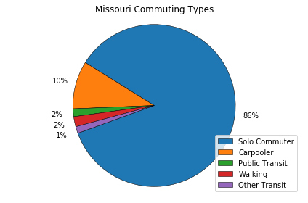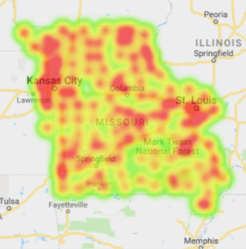

- What differences exist for commuting types across counties in Missouri?
- We considered a county metropolitan if it was in the Metropolitan Statistical Area for the top 3 cities in Missouri (Kansas City, St. Louis, Springfield).
- A Chi-Squared Test revealed that neither rural nor metro samples differed significantly from the Missouri averages for each commute type.
- An Independent T-Test revealed that the rates of Carpooling and Walking are significantly different between metro and rural counties. This could be due to the fact people in general live closer to their place of work and a smaller range of potential employers could account for more people riding together to work.

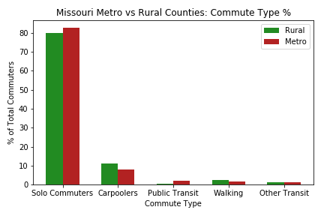

- What differences exist for commuting types within metropolitan areas in Missouri?
- When comparing the different metro areas in Missouri, we considered the entire Metropolitan Statistical Area for each of the top 3 cities in Missouri. The Metropolitan Statistical Areas for Kansas City and St. Louis included counties from neighboring states.
- An ANOVA Test revealed significant differences in Commuter %, Carpooler %, and Other Transit % among the cities.
- When subjecting each pair of cities to a T-Test for each category, only the difference in Carpooler % between Kansas City and St. Louis was deemed significant.
- Despite lower p-values in these T-Tests, the small number of counties in the Springfield metro area (5) prevented higher probabilities of differences with the other two metro areas.
- Springfield has a larger population of people who commute by walking which also correlates with a larger percentage of commuters who carpool. This could be due to the fact that many people who live in Springfield live or work on or near a college campus.
